**Enemy Style**

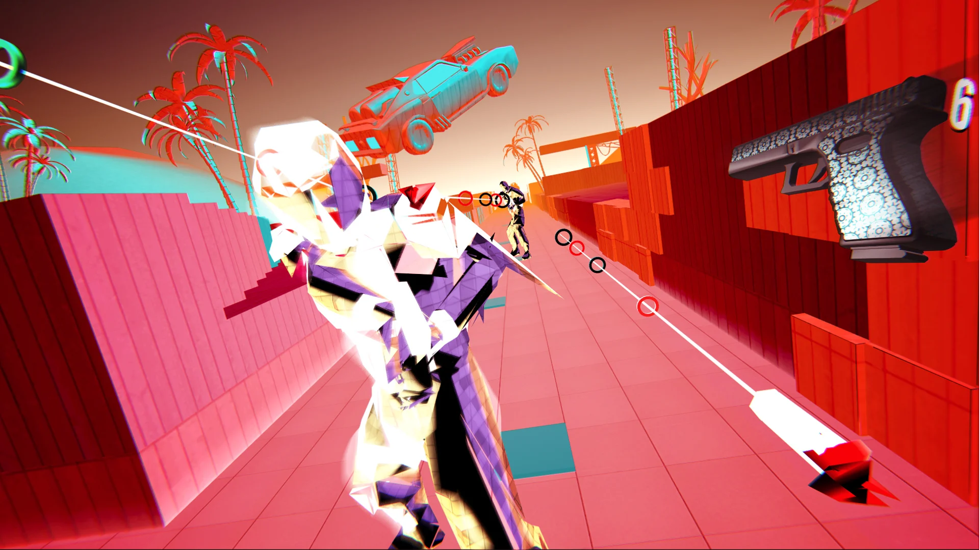

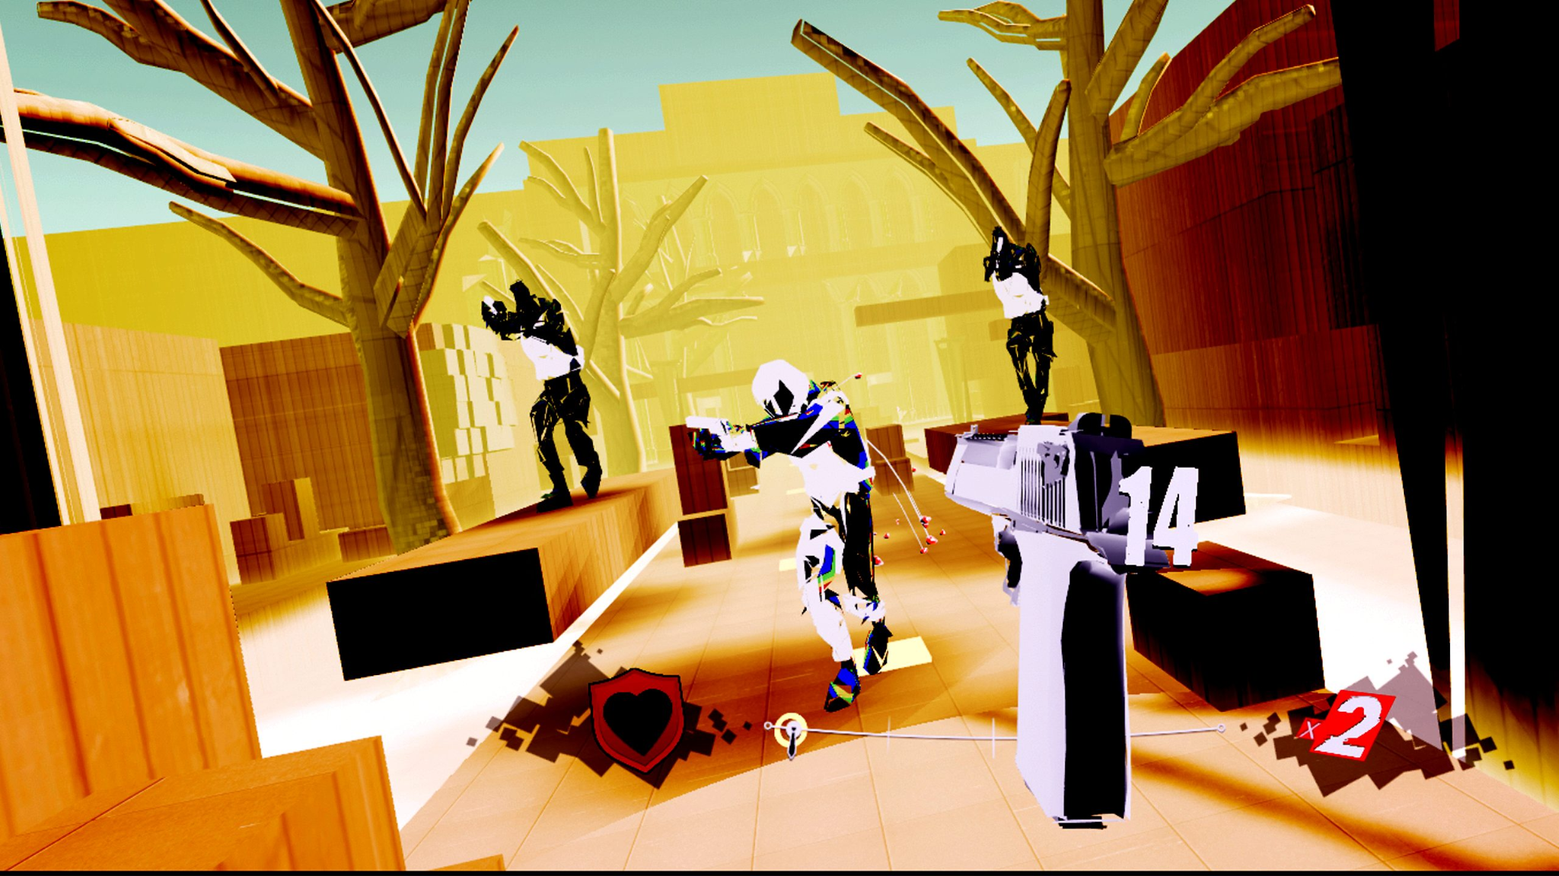

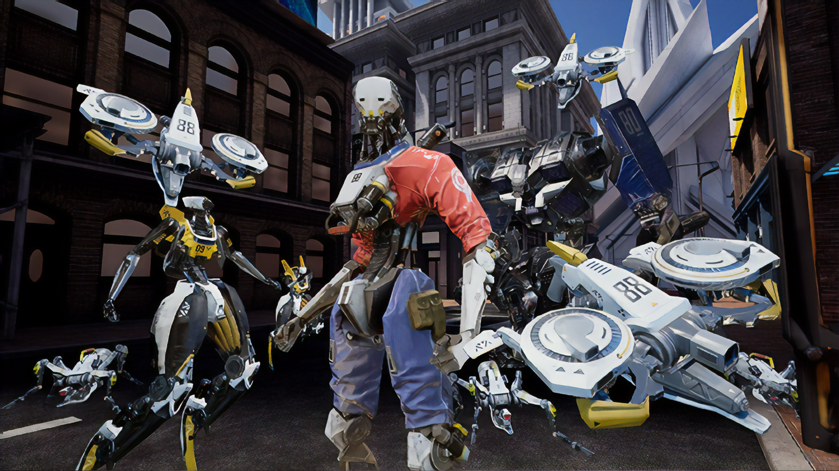

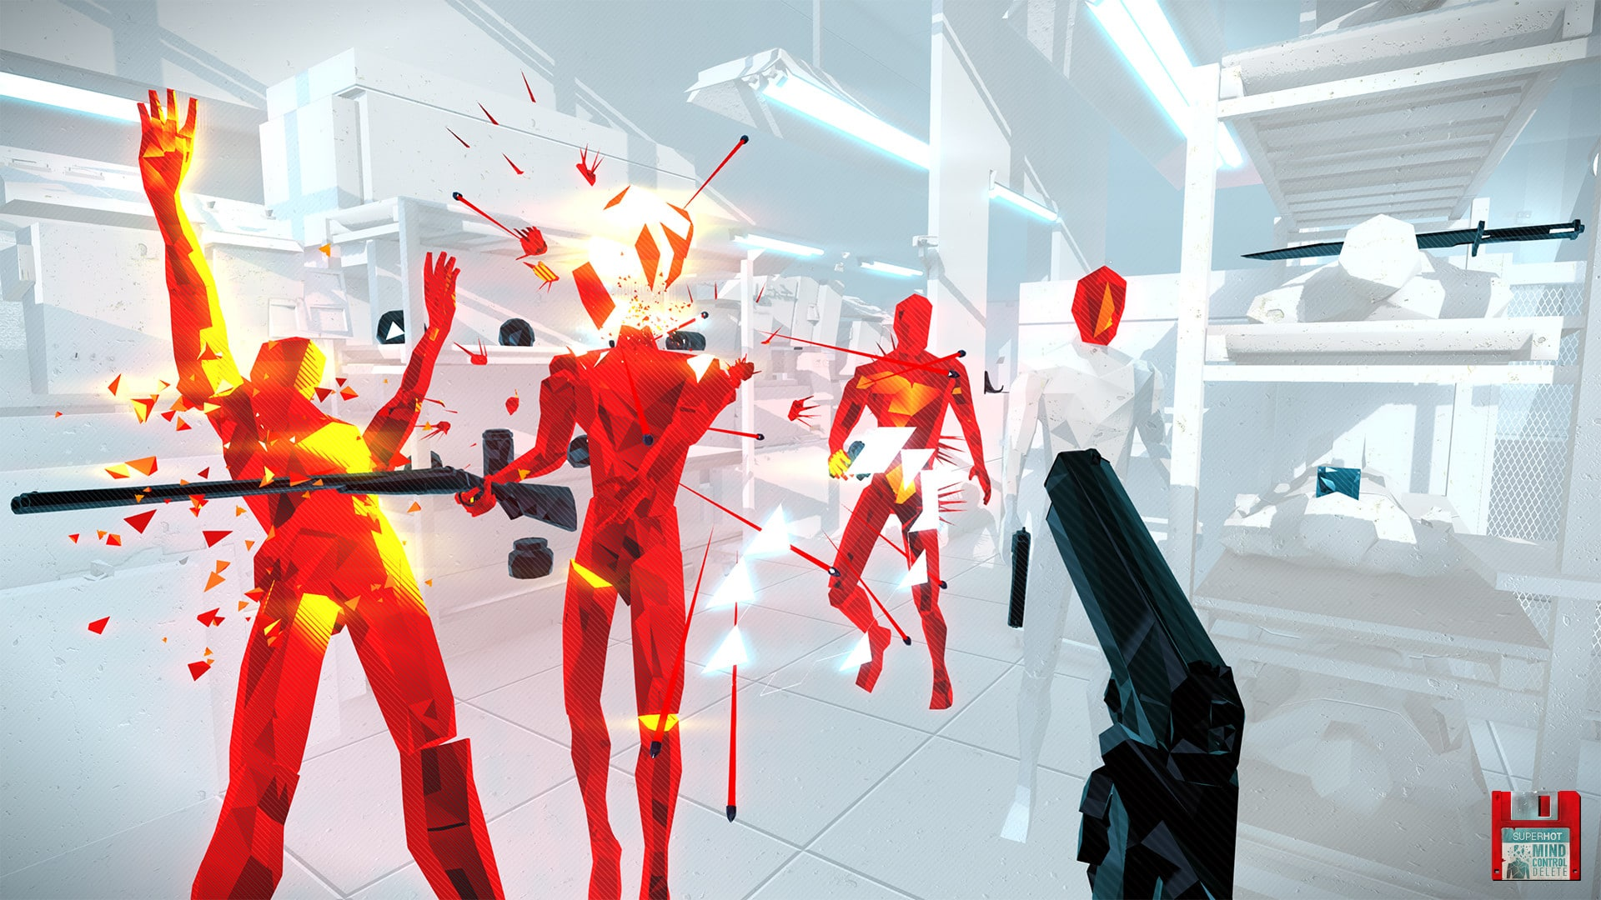

For the enemy part, sci-fi robots is what I thought at the first place. Sci-fi robot is one of my personal interests.

The stylized, monochromatic, low-poly humanoid enemy, I think this is really a good idea. But I think we need some artistic work in lighting to make sure they look really cool in the real game.

**Weapon Style**

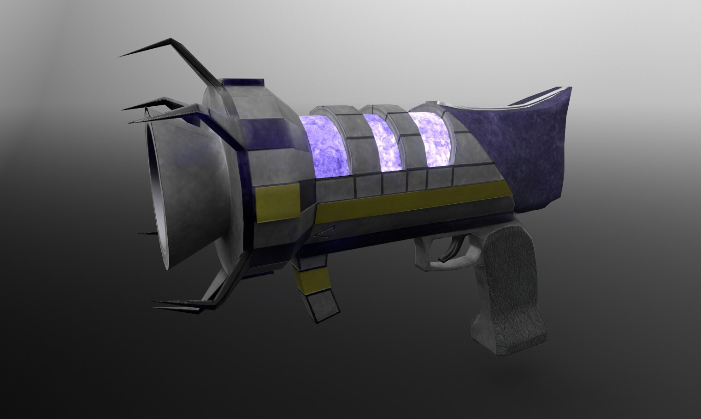

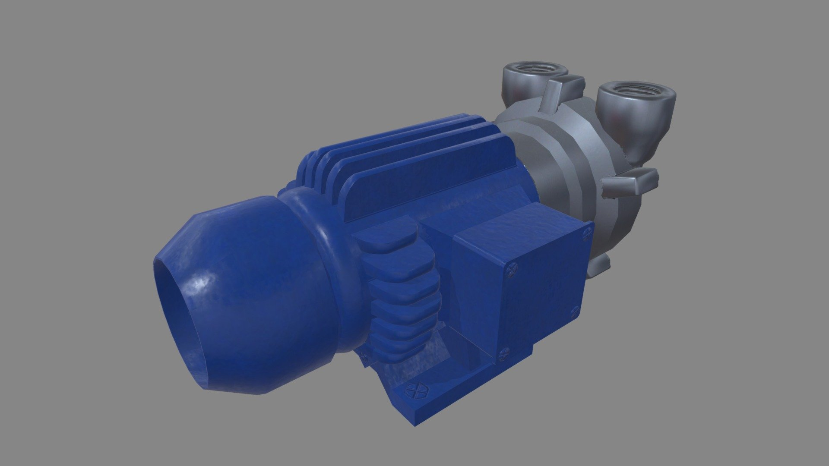

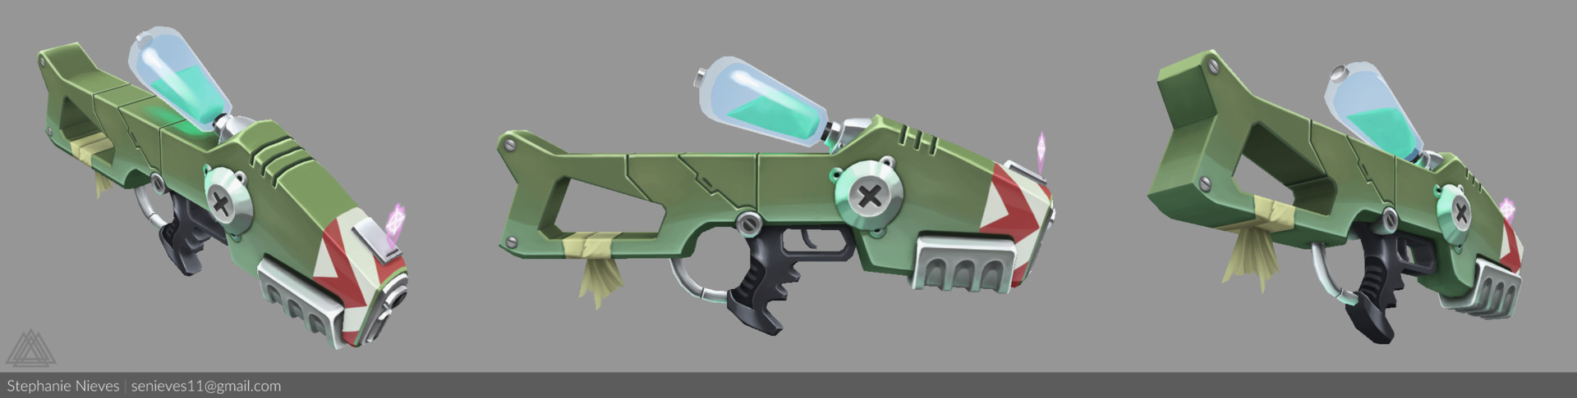

The weapon style is just based on the pics I found on the artstation. I really like this stylized guns with some unique features on it such as different heads that can be switched.

**Characte Style**

I don’t really we need such style for the players since our game is first person shooting game.

**Environment Style**

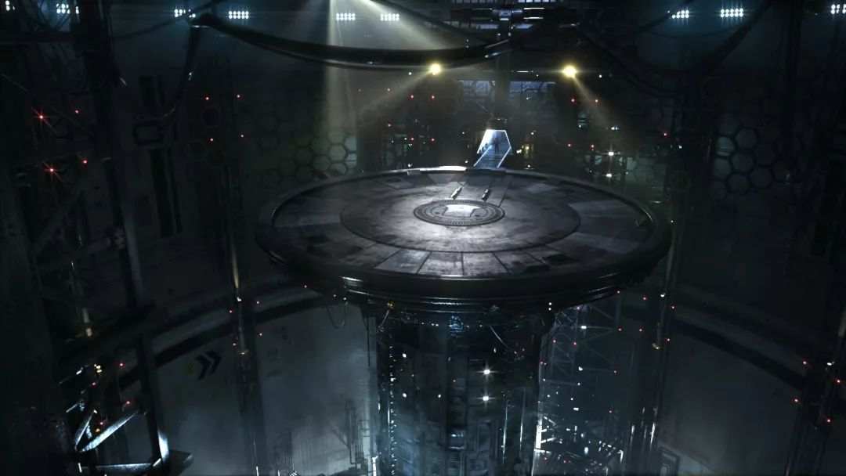

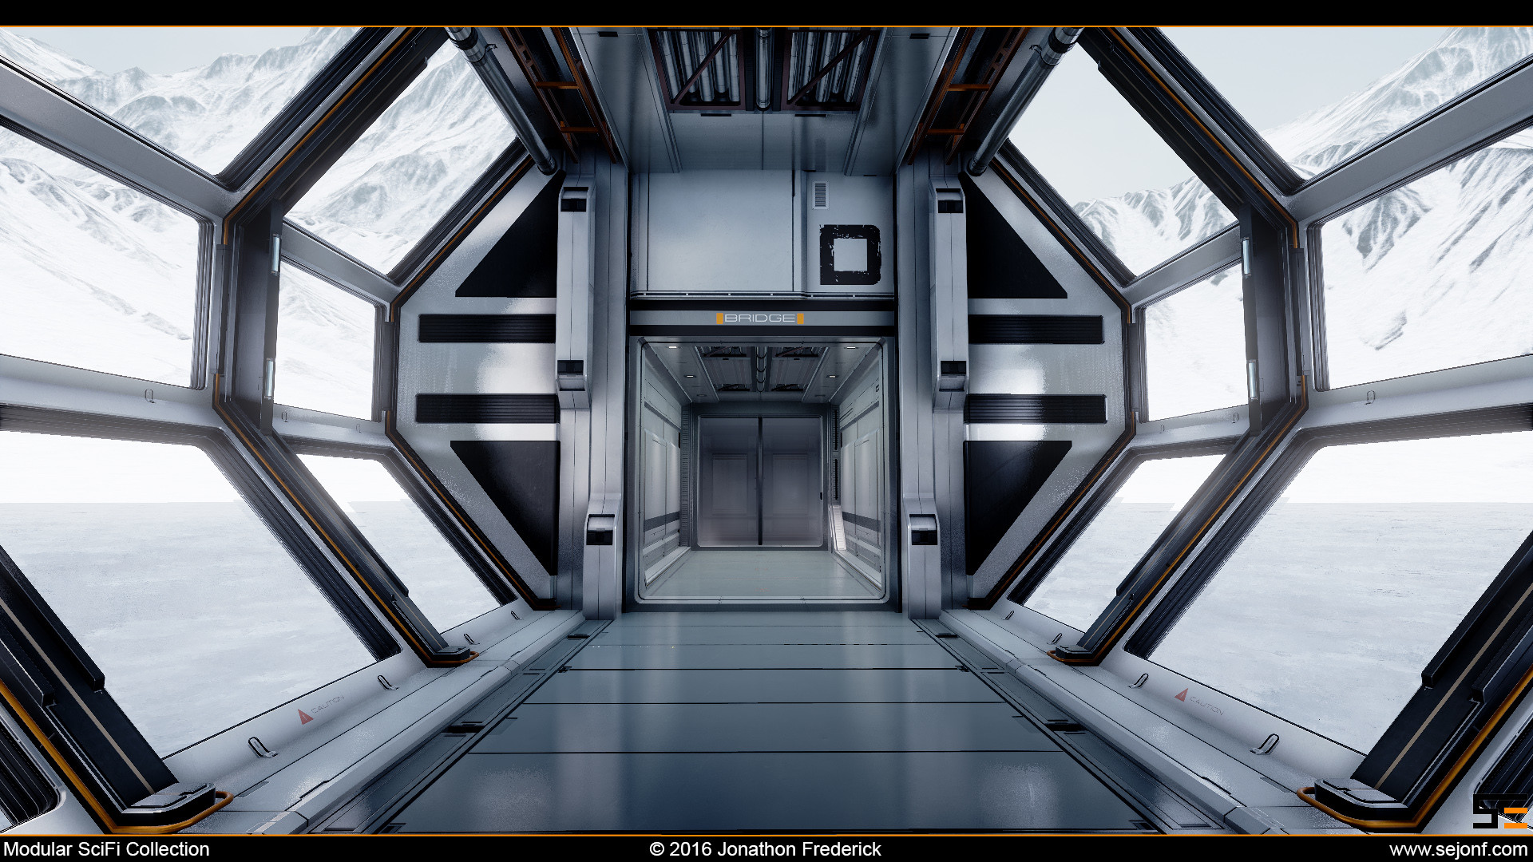

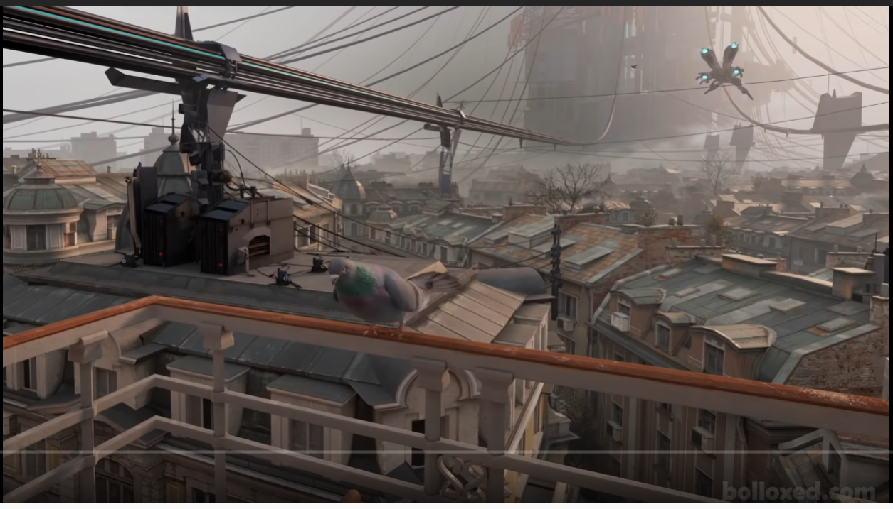

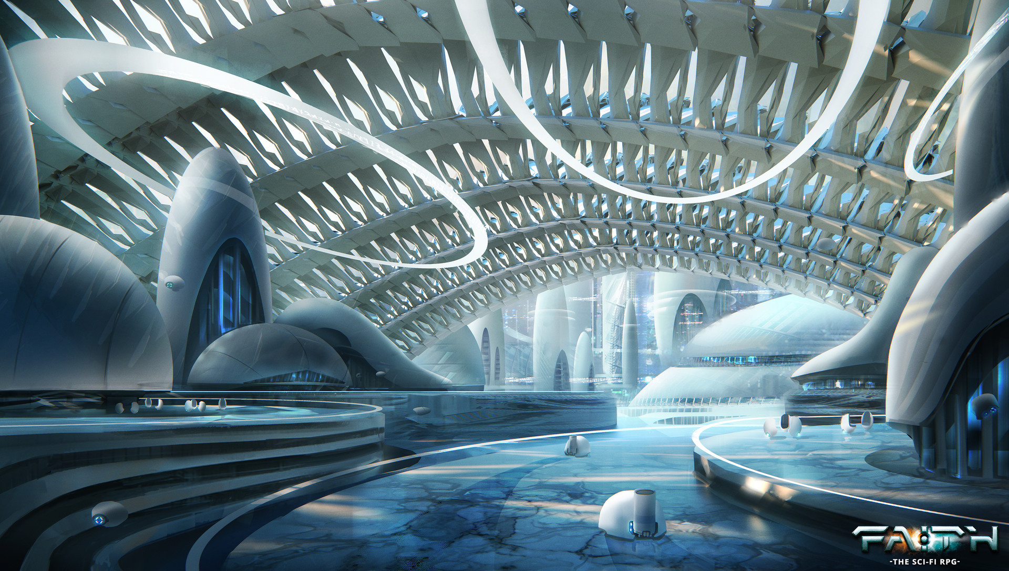

The whole environment style is scifi - realistic style. Players are fighting robots into a big sci-fi factory.

**Game play Style**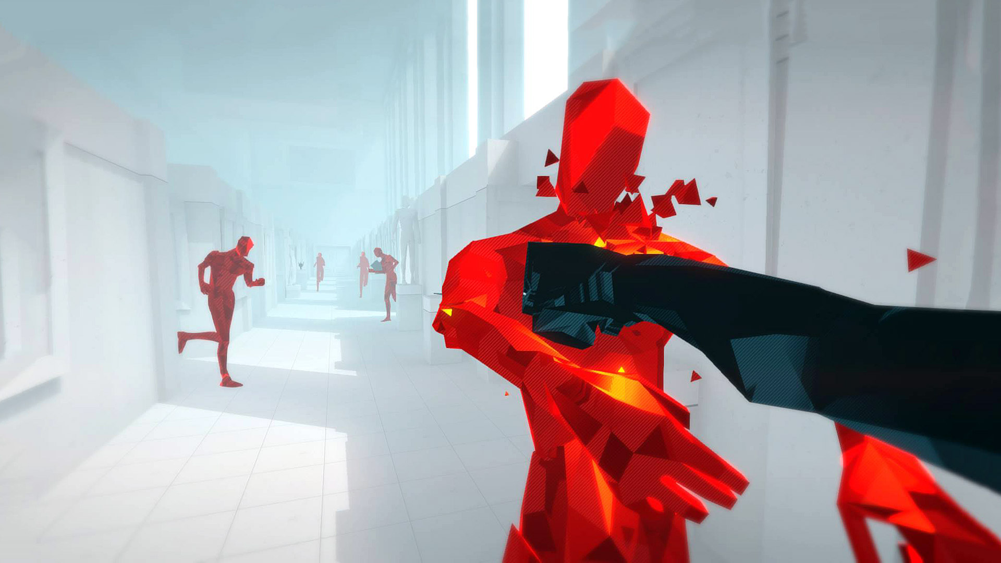

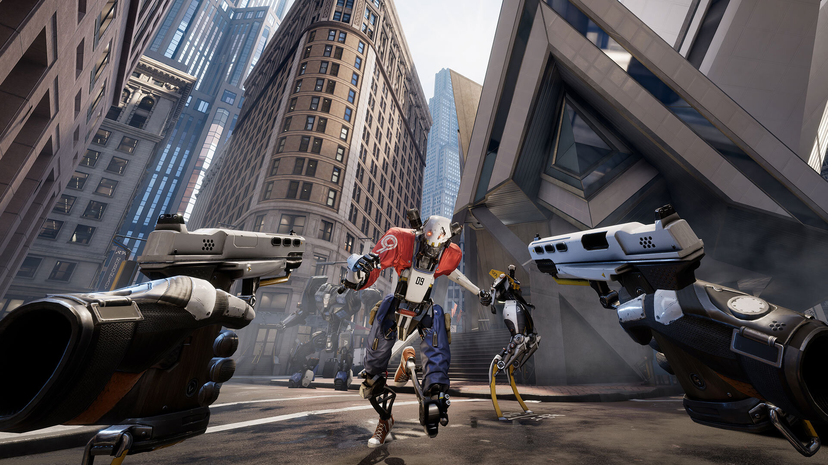

I really like the environment style of superhot and pistol whip. We could use this low-poly style to build our levels in the vacuum war.

For the gameplay part, what I thought is that players need to use the vacuum gun to absorb enemies’ bullets to become their own bullets, then use it to fire the enemies.